Understanding the Importance of Quarterback Performance on Contract Values

Executive Summary
Quarterbacks, crucial in the NFL, often lead their teams to victory. As the leaders of the offense, they control the entire game. The highest-paid players in the NFL are usually quarterbacks, highlighting their significant role (Badenhausen, 2020). This analysis investigates whether an NFL quarterback’s career performance influences their compensation. It examines the relationship between performance metrics and contract value based on game-play statistics. These metrics include passing yards, touchdowns, rushing yards, rushing touchdowns, pass attempts, interceptions, fumbles, pass completions, yards per game, touchdowns per game, and age. The normalized contract value of each quarterback serves as the target variable. The null hypothesis posits that performance metrics don’t significantly impact quarterback salaries, while the alternative suggests they do (Ko, 2024). This analysis helps teams and players make informed decisions about contracts, team composition, and player development. It addresses a practical business problem in sports management, ensuring contracts reflect performance trends and align with data-driven analytics.
This project utilized two CSV datasets: one for NFL player data and the other for contract data, both collected from Kaggle repositories. The first dataset, yearly_player_stats_offense.csv, contains yearly performance metrics for all NFL offensive players from 2012 to 2024, including demographic data, draft status, and seasonal and career-long performance metrics (Hyde, 2025). The second dataset, combined_data_2000-2023.csv, includes contract data for all NFL players from 2000 to 2023, with the variable value_norm representing the total US dollar value of their contract at signing normalized to the NFL salary cap for a given year (Liu-Sontag, 2023). The data was gathered by downloading the source files, verifying their integrity in Excel, and loading them into a Python environment using Pandas for analysis. These comprehensive data sets encompass 12 years of player data, performance metrics, and salary information, allowing for robust historical analysis and informed salary cap adjustments for each season. However, they lack the same number of years as Hyde’s dataset (2012-2024) and Liu-Sontag’s dataset (2000-2023), necessitating the deletion of rows from 2000-2011 for a consistent timeline. Additionally, the salary data doesn’t consider sponsorships, which could influence marketability and popularity, potentially limiting the model’s explanatory power. Aligning the datasets was challenging due to differing season conventions and column naming conventions; however, the player’s name and position columns from Hyde’s dataset, which matched Liu-Sontag’s convention, ensured accurate merging. Only the quarterback position was retained in the combined dataset, as the hypothesis focuses on quarterback salaries and their relationship to career performance, leading to the exclusion of other positions prior to data exploration and regression analysis.
The data extraction and preparation process utilized Python libraries, including Pandas (Pandas, 2025), NumPy (NumPy, 2025), Matplotlib (Matplotlib, 2025), Seaborn (Seaborn, 2025), SciKit-Learn (SciKit-Learn, 2025), and SciPy (SciPy, 2025), to load, clean, merge, filter, and visualize the datasets. After importing the data into Pandas dataframes, the columns were renamed, duplicates were removed based on QB-specific criteria, and irrelevant features or those with high missing values were dropped. Key variables were retained, categorical fields were encoded, age was binned, and summary statistics were generated. Univariate visualizations—including histograms, skewness measures, and boxplots—revealed that most variables were right-skewed and contained outliers. Correlation analysis, supported by scatterplots and a heatmap, revealed that all predictors were positively correlated with the target variable, and several features exhibited high correlations, indicating potential multicollinearity. Ridge regression was selected to address this issue through regularization.
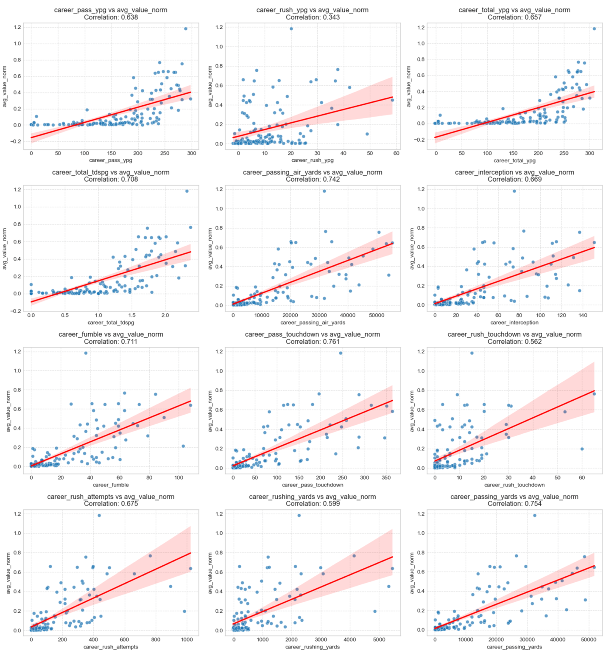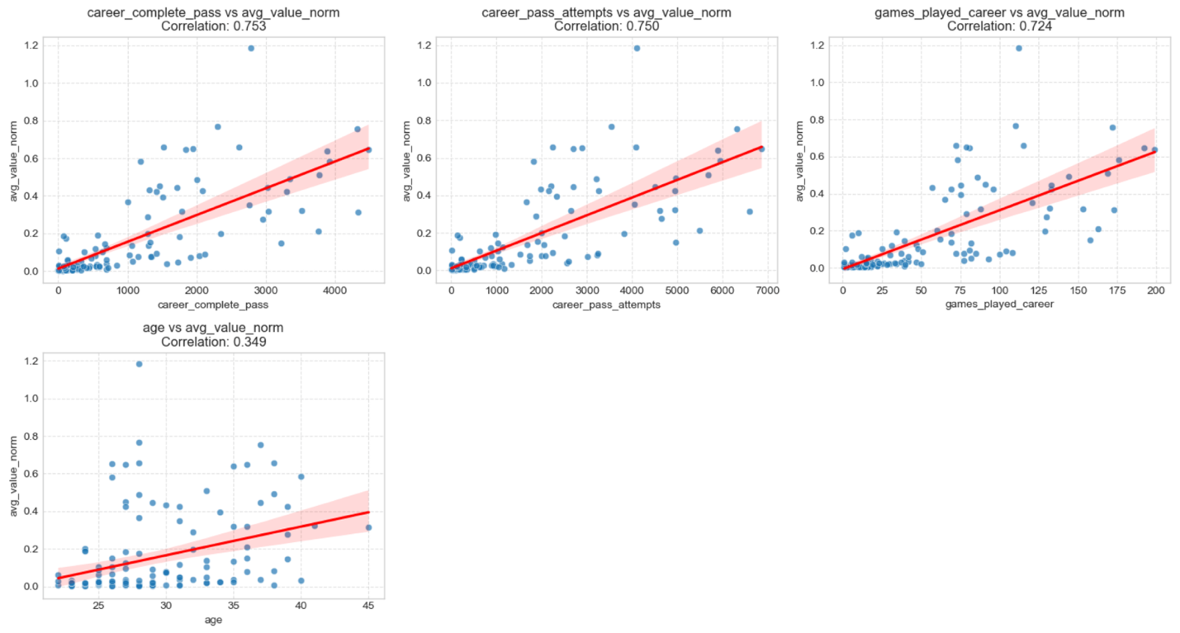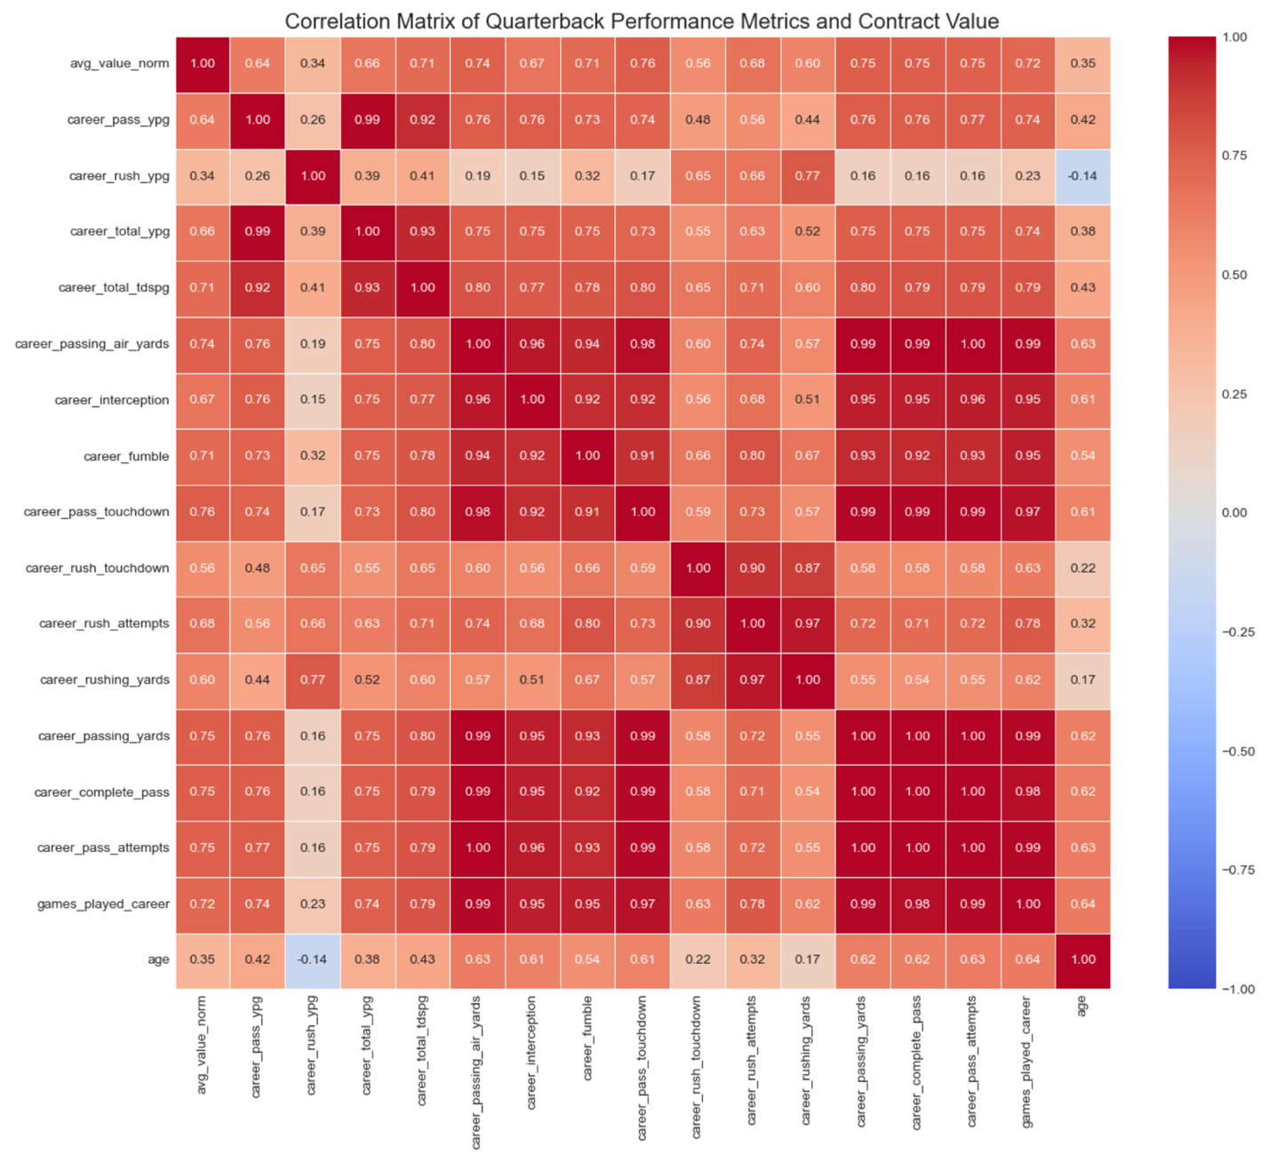
The modeling process used scikit-learn tools to split the data, select features, train models, and evaluate performance. After an 80/20 train-test split, SelectKBest was applied with both f_regression and mutual_info_regression to identify the most informative predictors and reduce overfitting. Linear regression was trained using the selected features to predict avg_value_norm and evaluated using R², with feature importance visualized in bar plots. Ridge regression was added to address multicollinearity through L2 regularization, while Random Forest regression was included as a non-linear, tree-based model that ranks features by impurity reduction. All three models were compared to assess their accuracy in predicting contract values.
A pipeline with StandardScaler() is created to train the models and predict Y, including mean squared error, root mean squared error, and R-squared. Pipelines are sequences of data processing steps where the output of one step serves as the input to the next. This enables organized and efficient workflows, streamlining tasks such as data preprocessing, model training, and evaluation. StandardScaler() is a feature scaling technique used in machine learning to standardize the values of numeric features. It transforms the data so that it has a mean of 0 and a standard deviation of 1, which helps improve the performance of algorithms sensitive to the scale of the data. This is crucial so that no single feature disproportionately influences the model due to differences in scale. The mean squared error (MSE) is a common metric that calculates the mean of the squared differences between actual and predicted values. The root mean square error (RMSE) is a statistical measure that quantifies the average difference between predicted values and actual values in a dataset. The actual and predicted quarterback values are visualized with a scatter plot.
The line graph illustrates that the optimal number of features in the linear regression model is 2, as this is when the R² value reaches its highest value of 0.55. This graph illustrates the results of the linear regression when SelectKBest with f_regression is applied. The selected features for f_regression with the highest scores are career_pass_touchdown and career_complete_pass, with scores of 133.82. and 126.48. When evaluating model performance with the selected optimal k values, Random Forest is the best, as its R² is 0.62, MSE is 0.02, and RMSE is 0.16. The actual and predicted QB contract values are also illustrated. It appears that most of the data is close to 0, with higher contract values gradually moving away from 0. When selected features are evaluated using mutual_info_regression, the most important features are career passing yards and career passing air yards, with scores of 0.57 and 0.55. 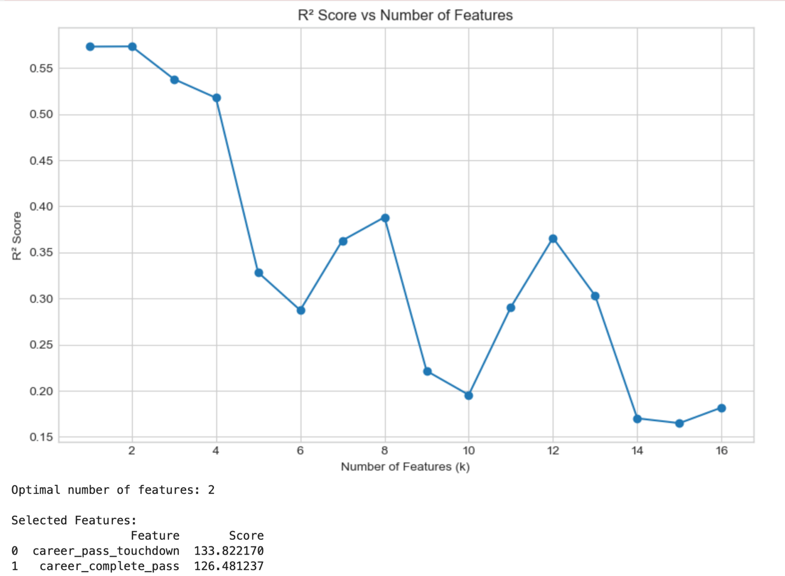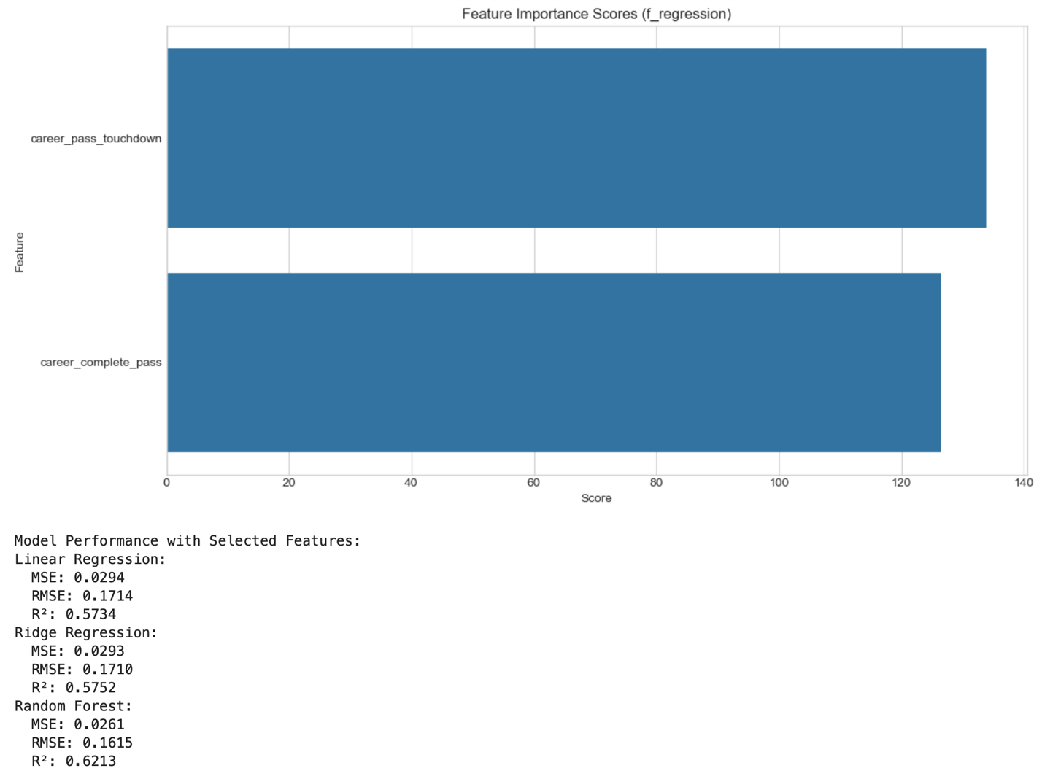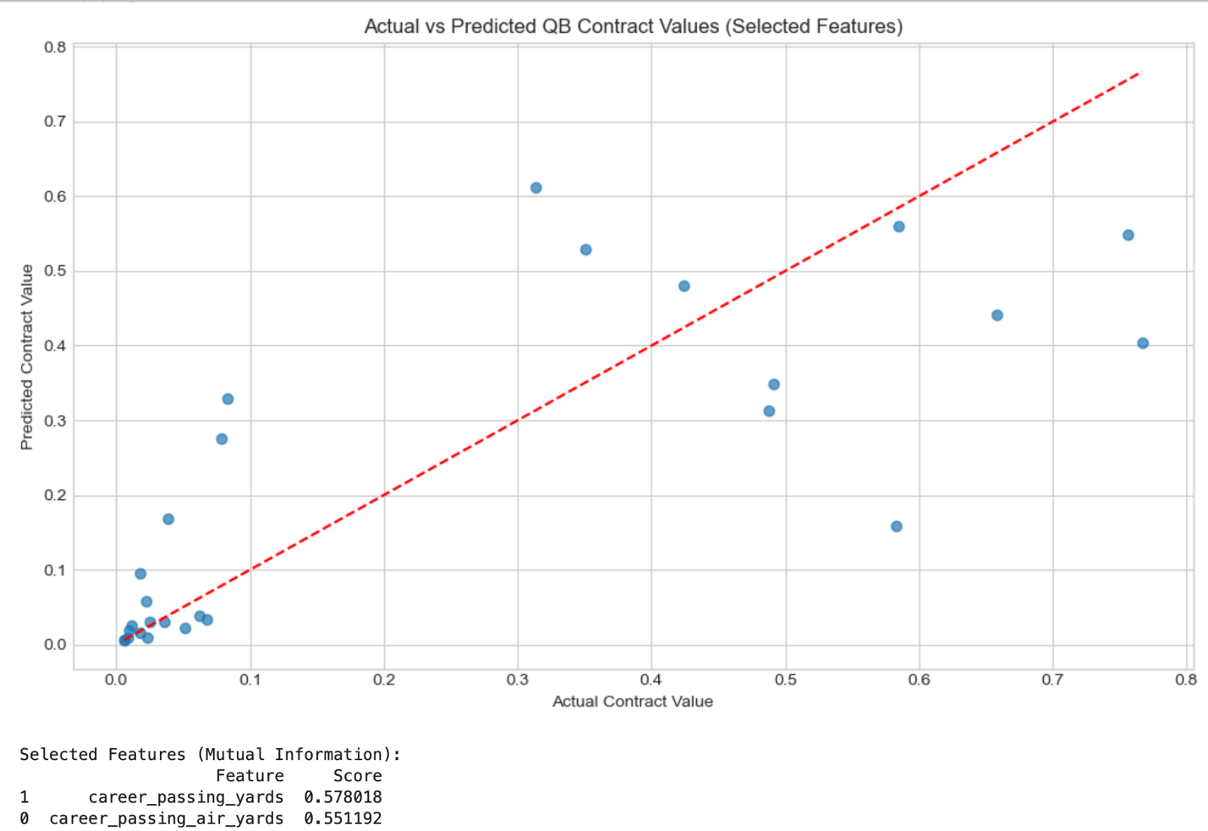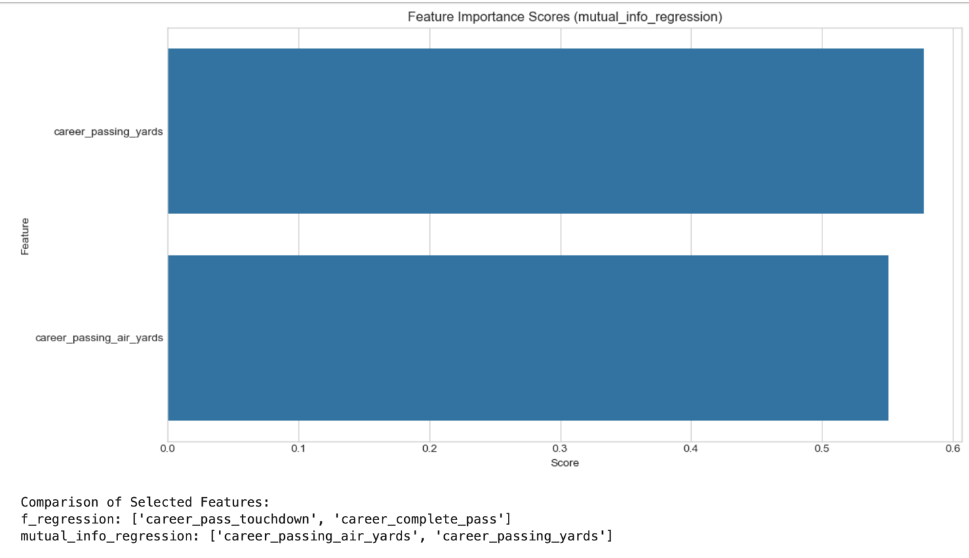
Residual analysis is executed for the best model, which is Random Forest. A random pattern of residuals emerges as the contract value increases, but it remains constant when examining contract values between 0.0 and 0.1. The residual mean is 0.01, and the residual median is 0. Since these values are close to zero, the model is unbiased. When viewing the histogram, it illustrates a normal distribution with slight variance on both sides of 0. The Q-Q plot illustrates data that mostly align with the line, with some minor variance between -0.5 and 0.5 of the theoretical quantiles, as well as variance around 1.5 to 2.0. There does seem to be some heteroscedasticity beyond the actual contract values of 0.1. This means that there may be some issues, such as non-linearity or outliers, within the data. This is also calculated with the standard deviation of residuals equal to 0.1608. The diagnostic plots for residuals help assess model fit and identify potential issues, such as heteroscedasticity or non-linearity. 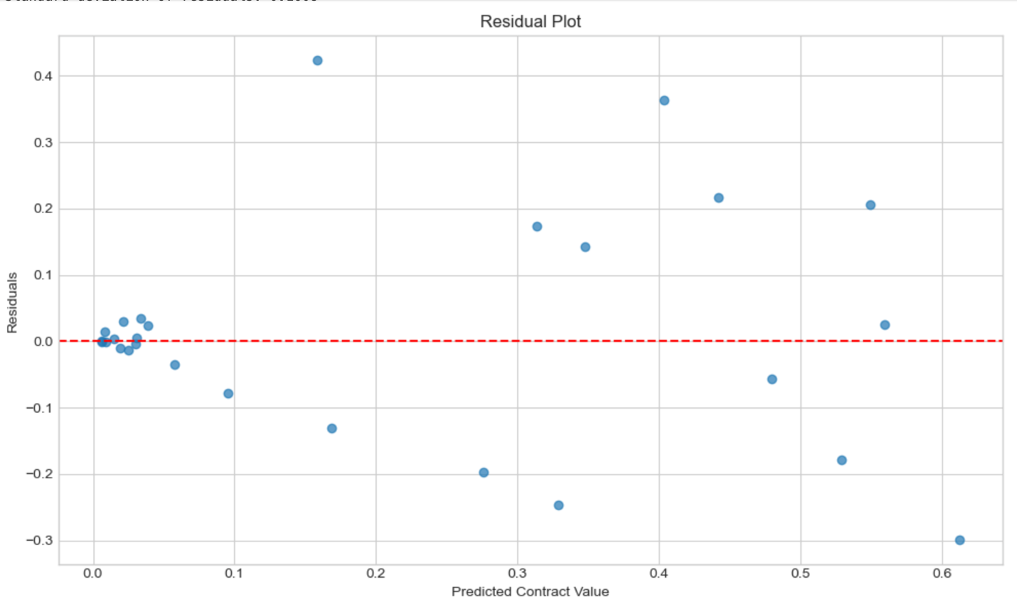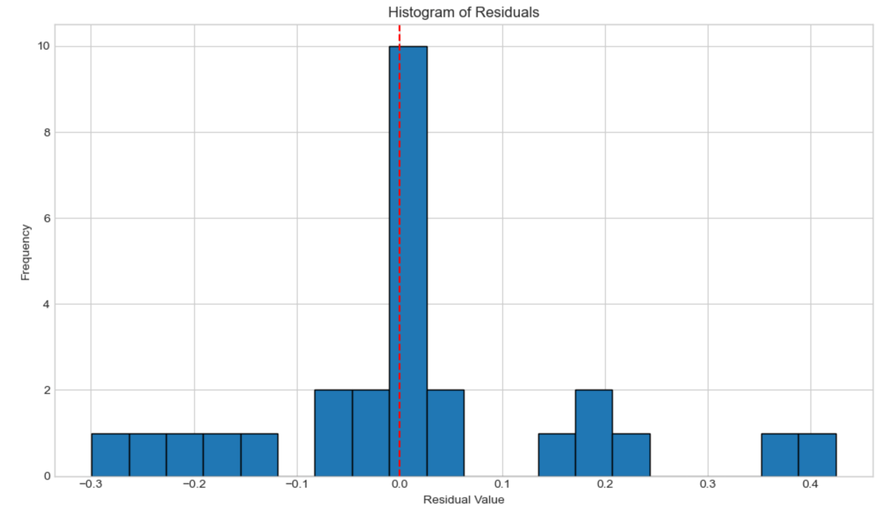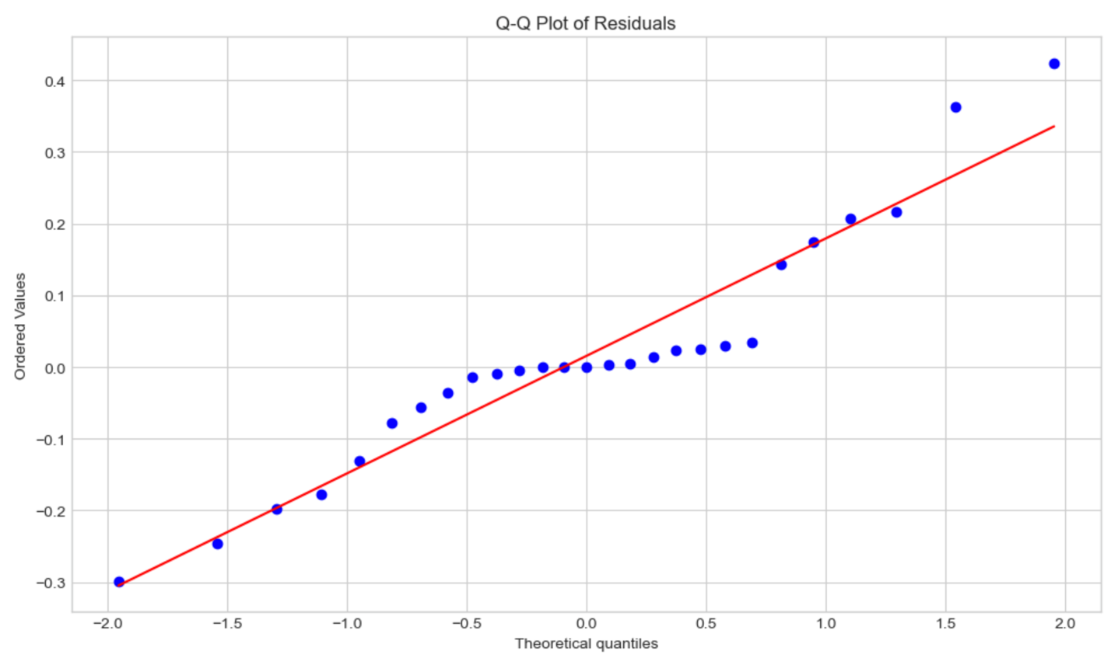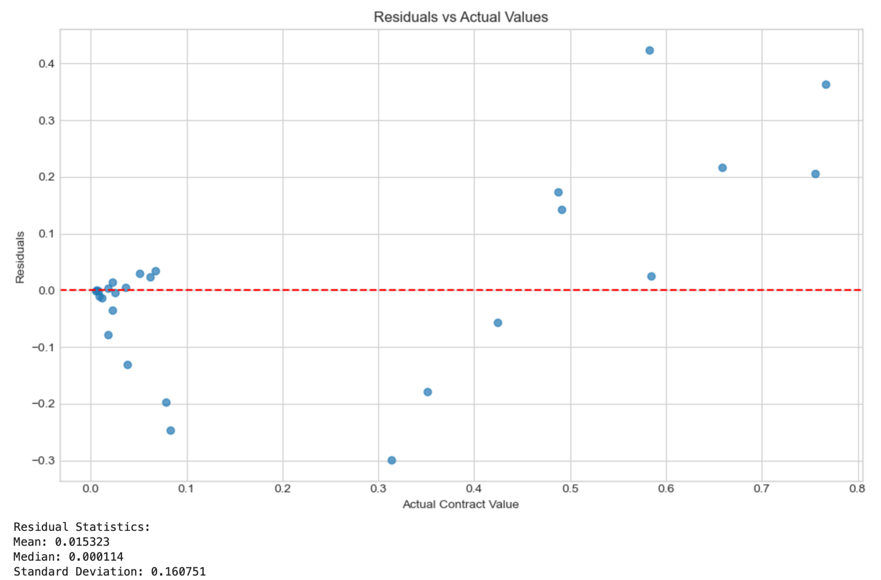
Several analytical tools and techniques have important limitations. Histograms can appear misleading when data ranges are adjusted, especially with variables that span large scales. Boxplots may misrepresent spread when distributions are skewed. Pandas and NumPy can struggle with large or complex datasets due to memory demands and limited support for non-numeric structures. Train-test splits can produce variable performance results depending on how the data is divided. Linear regression is sensitive to outliers, whereas ridge regression reduces variance at the expense of introducing additional bias. Random forests cannot extrapolate beyond the range of the training data. Feature-selection methods, such as SelectKBest, F_regression, and mutual_info_regression, each have drawbacks: they may overlook feature interactions, be heavily influenced by outliers, or yield results that are more difficult to interpret.
Some suggestions for future research include, but are not limited to, the following:
- Implementing cross-validation with GridSearchCV or RandomizedSearchCV to optimize model parameters rather than using fixed values
- Using Lasso Regression for feature selection
- Using filter methods such as forward and backward feature selection, as well as recursive feature selection
- Examining the strength of an offensive line and its influence on quarterback compensation
- Evaluating salaries for wide receivers and running backs to determine whether these positions improve a quarterback’s ability to be paid more
- Longitudinal studies could be conducted to follow quarterbacks seasonally to see if performance changes with time and how that may affect compensation
- Combining certain predictors and averaging them or calculating efficiency ratios to assess the value of a specific metric, such as the TD-to-INT ratio
The analysis addresses the research question: “Does an NFL quarterback’s performance influence their compensation?” The most important benefit of this analysis is that it identifies the most important performance metrics that influence a quarterback’s contract value. NFL teams are given a salary cap that they must adhere to when signing players. These teams must deliberate on numerous metrics to determine whether they should continue paying their players. This is important because these teams are trying to win Super Bowls while spending as little as possible to save money for other positions on the roster if needed. If a player is overpaid, then it takes away the team’s ability to spend money on other positions where they may be weak. The findings of this study have the potential to enhance team management, expedite decision-making, and ultimately lead to more informed decisions regarding which quarterbacks to sign. Based on the analysis of 132 unique quarterbacks over the course of 12 seasons, the most important features that influence contract value are career passing touchdowns, career complete passes, career passing air yards, and career passing yards with scores of 133.82, 126.48, 0.57, and 0.55. Given the skewness of these variables, it appears that a few high performers are valued significantly more for their performance than the average quarterback. This demonstrates that a quarterback is valued more for their passing ability than their rushing ability. It also illustrates that the most important feature is passing touchdowns, which makes sense since teams need to score points to win games. The best regression model used, Random Forest, explains 62.1% of the variance in contract values, indicating acceptable explanatory power.

References:
Badenhausen, K. (2020, September 11). The NFL’s Highest-Paid Players 2020: Bosa Tops with $44 Million, Mahomes Sits Out. Retrieved November 10, 2025, from https://research.ebsco.com/c/25xrgu/viewer/html/aildt534az.
Hyde, P. (2025, August). NFL Stats 2012-2024: NFL Stats for Projections [Data set]. Kaggle. https://www.kaggle.com/datasets/philiphyde1/nfl-stats-1999-2022/data?select=yearly_player_stats_offense.csv
Ko, K. (2024, December). Quarterback Win Rating: A Superior Methodology for Evaluating and Compensating Quarterbacks. AAYAM: AKGIM Journal of Management, Vol. 14 Issue 3, p1-7. 7p.
Liu-Sontag, N. (2023, August 27). NFL Contract and Draft Data: Contains NFL contracts and draft pick data for players between 2000 and 2023 [Data set]. Kaggle. https://www.kaggle.com/datasets/nicholasliusontag/nfl-contract-and-draft-data
Matplotlib (2025, February 27). Using Matplotlib. User Guide. Retrieved November 5, 2025, from https://matplotlib.org/stable/users/index.html
Ngugi, J. (2022, May 21). Handling Missing Values – Data Science. Medium. Retrieved September 24, 2024, from https://ngugijoan.medium.com/handling-missing-values-data-science-7b8e302264ee
NumPy (2024, December 14). NumPy User Guide. Retrieved November 5, 2025, from https://numpy.org/doc/stable/user/
Pandas (2024, September 19). Pandas User Guide. User Guide. Retrieved November 5, 2025, from https://pandas.pydata.org/docs/user_guide/index.html
Scikit-Learn (2025, November). User Guide. Retrieved November 21, 2025, from https://scikit-learn.org/stable/user_guide.html
SciPy (2025, February 17). User Guide. Retrieved November 13, 2025, from https://docs.scipy.org/doc/scipy/tutorial
Seaborn (2024, January 1). Seaborn User Guide and Tutorial. Retrieved November 5, 2025, from https://seaborn.pydata.org/tutorial.html

